We sympathize with Melody Galang in your bereavement.

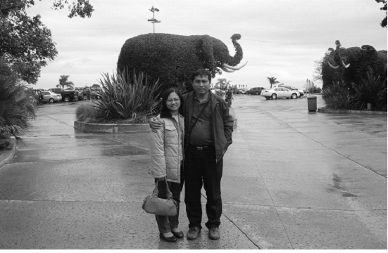
The deceased Melody with her husband, Pastor Jones Galang in 2006

▶ We, Osan Labor Culture Center and Dasom Church, sympathize with Melody Galang in your bereavement. She, Pastor Jones Galang's wife, has passed away of the stroke at 10 'clock 10th Feb. 2008 at St. Vincent Pampanga Mexico-city hospital in the Philippines.
She is survived by her husband as a labor missionary in Korea and 3 daughters Pamela, April Joy, Fatima Gayle.
May God's comfort and all comrades' prayer be with the family!

 | PHILIPPINES | KOREA
Contact No. | Home) 63-45-875-7479  Cell) 63-92-7875-0085 | Office) 81-31-372-9301  Cell) 81-10-8695-0241
Bank Account | Metro Bank  Dolores San Fernando Branch # 296-3-29603725-8  Pastor Galang jr. | Shinhan Bank (신한은행)  325-04-772843 Jones Galang

From all members of the Osan Labor Culture Center and Dasom Church

