News from Around the Region

Philippines

KMU on the DOLE “strike-free” brag: “You have made strikes illegal in the

“The seeming industrial peace being bragged about by the Department of Labor and Employment (DOLE) Secretary Arturo Brion comes not from happy, satisfied work force but is enforced by the barrel of a gun.”
This was the reaction today of Elmer “Ka Bong” Labog, National Chairperson of the Kilusang Mayo Uno (KMU) Labor Center to the press release of Sec. Brion regarding the “strike-free” labor environment for the first quarter of 2007
India
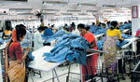

Women working in the garment industry face untold misery and the roles expected of them at home by society have only increased their woes, says S Senthalir
As dawn casts its spell on the Silicon City, the breeze ruffles the leaves with its gentle touch greeting the legions of garment workers who stride down the roads that lead to their factories. Their brisk movements would even stagger an army regiment for a moment.
The garment industry in Bangalore predominantly comprises women, who constitute 85-90 per cent of the work force in the garment industry, thus being the second largest employer of women after the beedi industry.
Feminists, who had worked towards breaking the shackles that confined them within the house, would have been pleased with these statistics.
But for Saakkamma, a garment worker, there is little time to reminisce the valour of her predecessors as she has to rush to the factory after completing her domestic chores. Each day, she musters up energy not only to face the Herculean task but also the humiliating comments directed at her by her superiors

Newzealand

The union movement is gravely concerned about the deteriorating human rights situation in the Philippines and are urging our Prime Minister to raise this with Philippines President Gloria Macapagal Arroyo during her New Zealand visit next week,” CTU president Ross Wilson said today.
CTU’s National Council was addressed today by Dennis Maga, spokesperson for the Free Ka Bel Movement in the Philippines, an alliance of organisations calling for the immediate release of trade union leader and Congressman Crispin “Ka Bel” Beltran, who has been in detention since February 2006. Maga is in New Zealand to coincide with visit of the Philippines President next week.
“The Prime Minister raised human rights breaches in the Philippines with President Arroyo last year and a CTU resolution today called on Helen Clark to protest in the strongest possible terms during the visit of President Arroyo next week the killings of activists, for those responsible be bought to justice and for Ka Bel to be immediately released.”
The CTU resolution is as follows:

China
Some U.S. labor union leaders are visiting China to end a long boycott on dealing with the country's state-controlled labor federation. The delegation will meet with Communist Party officials and give a seminar on collective bargaining. Daniel Schearf reports from Beijing.
Delegates from the Teamsters union and other members of the "Change to Win" federation are in China to meet with Chinese officials and the official All China Federation of Trade Unions.
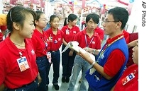
Manager holds staff meeting with employees of Wal-Mart outlet in Beijing (Aug 2007 file photo)
The visit marks a change for U.S. unions, which previously shunned contact with China's government-run labor organization.

Malaysia

UNI Telecom Affiliate, NUTE, has signed with Telekom Malaysia the 7th Collective Agreement on 11th may 2007 which gives the employees between 10% to 18% increase to their monthly income. COngratulations to NUTE for a great new contract.
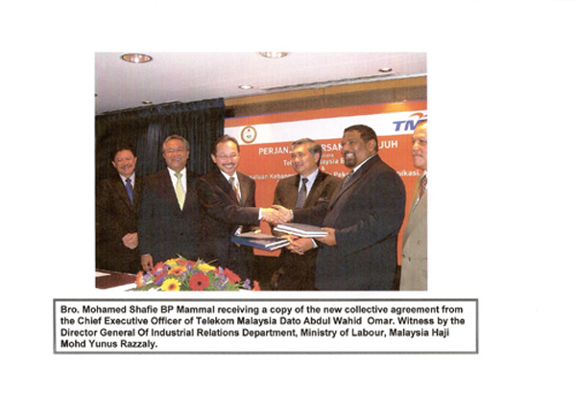

7th Collective Agreement
Between Telekom Malaysia Berhad (TM)
And
National Union of Telecommunications Employees (NUTE)
Malaysia 2007-2009
Telekom Malaysia and NUTE signed the 7th Collective Agreement on 11th may 2007 which gives the employees between 10% to 18% increase to their monthly income.
The following are some of the highlights of the 7th agreement:
1. Salary increment 5.5% Across the board+ 1 increment
2. Cost of living allowance (SRA) RM 50 (New)
3. Housing allowance RM 90>RM 120 ( increase 33%)
4. Subsistence allowance Between RM 40 to RM 50
(increase 25%)
5. Accommodation expenses Between RM 110 to RM 130
( increase 36%)
6. Mileage Claims RM 0.55 increased to RM 0.65 per KM
( increase 18%)
7. Driving allowance Between RM 3 to RM 9
( increase 28-66%)
8. Shift allowance 1st shift RM 40 > RM 60
( 50% increase)
2nd shift RM 60 > RM 90
( 50% increase)
9. Transfer/Shifting allowance Between RM 300 to RM 600
( 50% increase)
New Salary scales:

Indonesia

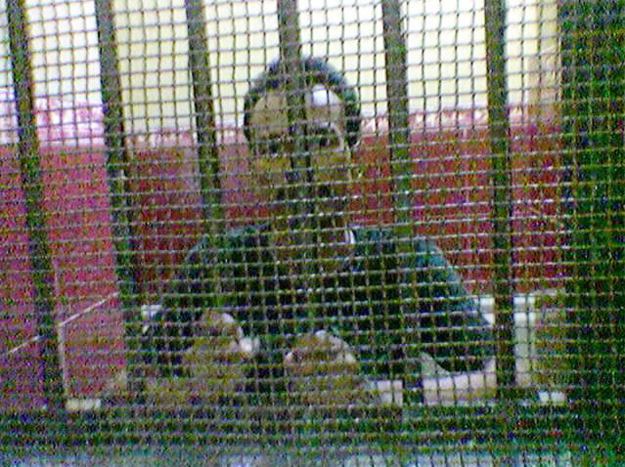

ACT NOW! Furniture worker in Indonesia still in jail for particpating in May 1 rally

Indonesian BWI Affiliate FKUI–SBSI (Federation of Construction, Informal and General Workers Union) reports that one of its members, a chairman of one of its local unions got detained by the police; for participating in a peacful demonstration on 1 May. A few days ago, the FKUI–SBSI reports, after attempted negotiations for his release, Sarta bin Sarim was transferred to
Tanggerang Prison for "security reasons". Since then the situation for Mr. Sarta has become worse.

Thailand
What you won't hear from a Thai worker
At several farms visited by the delegation, Lek tried to involve the Thai workers in conversation. They were cautious. Most said at first that everything was fine. As the talk went on, however, a few agreed to open up. It emerged that in order to reach Israel, they had each paid between $6000 and $9000 in mediation fees. Their wage amounts to 13 NIS per hour (about $3, two-thirds of the legal minimum). Given living expenses and interest, it will take them about two years of labor just to repay the money they borrowed in order to come.
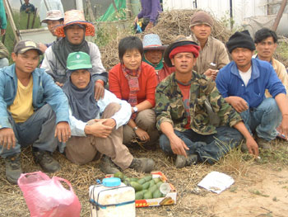
thai delegate Lek with Thai workers
We learned further details from Anat Gonen, who is responsible for the agricultural sector in Kav la'Oved (Worker's Hotline). Also to her, she said, they fear to complain.
"The Thai worker gets his salary only after a delay of three months. This keeps him from leaving his employer. Officially he makes the minimum wage of $5 per hour, but if we take account of the fact that he works from 13 to 15 hours per day, the actual salary falls far below that. The boss generally keeps two sets of books, one real and one official, so that if an inspector should happen to come, everything looks fine. On days when the weather is too bad for work, the Thai gets nothing. He is also subject to human trafficking. Since every farmer gets a quota, a farmer who has no need of a worker sells part of his quota to another farmer. But because the Thai is bound to a specific farmer whose name appears in his passport, if he's caught working for a different one, the one who bought him, he is liable to be deported. He then loses his ability to repay his debt.
"You're probably wondering what happened to law enforcement. Where, in all this, is the Ministry of Industry, Trade and Labor? They generally accept what the employer tells them. And suppose they ask the worker? It is doubtful whether he would tell them the truth. Fear is in charge.

Japan

Payments for workers' stress hit record
THE ASAHI SHIMBUN
A record 205 individuals qualified for workers' accident compensation insurance in fiscal 2006 after being diagnosed with depression and other psychological disorders brought about by work-related stress, the health ministry said Wednesday.
The figure, which is about 1.6 times that of the previous year, offers the strongest indication yet that despite better economic conditions, life for the average Japanese worker has not improved substantially.
Of the 205 cases, 65 led to death by suicide and one involved an attempted suicide, according to the Ministry of Health, Labor and Welfare.
Labor ministry officials said long working hours and the spread of performance-based pay scales were the likely causes of the sharp increase in workers' compensation cases involving psychological problems

Singapore
8.000 foreign workers celebrate May Day gathering at the zoo
By Dominique Loh, Channel NewsAsia | Posted: 13 May 2007 2304 hrs

SINGAPORE : Some 8,000 foreign workers took a day off and headed for the zoo.
The annual "May Day Outing for all Nationalities" is NTUC's way of recognising and appreciating workers from all corners of the world.
And for the first time, representatives from various embassies and high commissions were also invited.
Among the celebrations were dance items from various countries, traditional games and snacks.
NTUC hopes the gathering will help foreign workers in Singapore feel more at home. - CNA/de

Pakistan
Multan: Food Industry Women Workers Lead May Day Rally
The IUF-affiliated National Federation of Food, Beverage and Tobacco Workers jointly with the Working Women Federation organised a workers meeting in the industrial area of Multan to mark May Day. (Multan has a population of about 4 million people and is an industrial centre in the province of Punjab).
The meeting was attended by leaders and workers from different unions and women workers from the food industry (who are not in unions). It was first time in Multan that any activity was organized in the factory area on May Day. Although the factory area has many businesses, to date no May Day activities have occurred in this part of the city. The Women Workers Federation chose to organise the meeting at a place near to workers’ homes and workplaces.
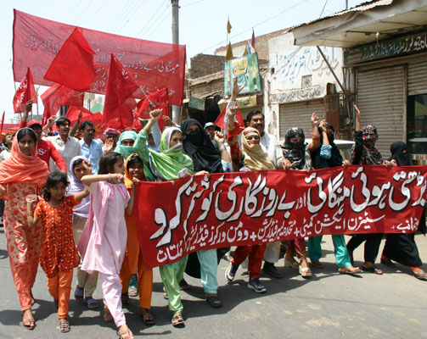

Attendance at the May Day meeting was affected by the Punjab Chief Minister’s visit to Multan on 30 April, which included a public address. Government officers were instructed to make the Chief Minister’s event “successful”. They booked much of the city’s private transport for the meeting. The Department of Labour and Manpower asked factory managers to send workers to the Chief Minister’s speech and factory owners were given permission to keep factories open on May Day. The Labour Department un-officially gave an incentive to the factory owners and abolished the May Day holiday. The workers, especially in small establishments, were forced to work on May Day so they were unable to attend the celebrations and rallies on that day. Union leaders criticised the labour department’s attitude to allow factory owners to run their establishments on the national holiday.
Nepal
GEFONT Isssues messge, commorates miliions workplace deaths >
4/29/2007
April 28- This year GEFONT participated in a joint programme organised by all three BWI affilites, which are the affiliates of ITUC affiliated natioal centres in Nepal including GEFONT. In memory of Dead and Injured Workers, who die or are injured at work as a result of unsafe working conditions, Nepali unions also marked 12th commemoration day today.
Issuing a press release GEFONT has quoted ILO statistics-"almost 2.2 million people die in accidents or due to illnesses related to their work each year, over 270 million workers are injured at work and almost 160 million suffer from illness caused by their jobs."
"Today we are condemning the use of asbestos in all forms. Workers are still being exposed to asbestos and 100,000 people die each year due to contact with this substance" the message has also reaffirmed the ITUC General Secretary Guy Ryder's position- "A total ban on the sale and use of asbestos must be introduced as a matter of urgency."
GEFONT compared Nepali situation with global context. "In Nepal there is still not identified any occupational disease, w don't have single expert on medical field, which has specialized on occupation diseases. Thus it is obviously natural there is insufficient or almost provisions in our labour legislation to protect victim of occupational diseases."
GEFONT message has given brief account on when and how this day has been commemorating in Nepal. It ha also acknowledged joint initiatives taken by GEFONT and other partners.
The tradition of April 28 is started since 1989 by the unions of Canada and USA. This day was officially declared as International Commemoration Day for Dead and Injured Workers from UN in 1996.

All news from www.labourstart.org
If you have any news items that you would like included in the news round-up, please email nanakorn@gmail

