FREEDOM for KA BEL is
JUSTICE for the TOILING MASSES.

FREE KA BEL NOW!

International Forum for Ka Bel’s Freedom

07 May 2007 / Manila, Philippines

07 March 2007

A network of

human rights advocates

calling for freedom and justice

for Ka Bel

CONVENERS

Hon. Teofisto Guingona
Former Vice President
of the Republic of the Philippines

-Legislators-

Senator Jamby Madrigal
Representative Edcel Lagman
Representative Roseller Barinaga

-Labor and Human Rights Organizations-

Elmer “Ka Bong” Labog
Kilusang Mayo Uno (KMU) Labor Center
Cherry Clemente
Anakpawis (Toiling Masses)
National Political Party
Carmen “Nanay Mameng” Deunida
Kalipunan ng Damayang Mahihirap (KADAMAY) urban poor alliance
Atty. Remigio Saladero, Jr.
Pro-Labor Assistance Center (PLACE)
Daisy Arago
Center for Trade Union and Human Rights (CTUHR)
Donato Continente,
Samahan ng mga Ex-Detainees Laban sa Detensyon at para sa Amnestiya (SELDA) / Organization of Ex-Detainees against Detention and for Amnesty
Connie Bragas-Regalado
Migrante International
Ferdinand Gaite
Confederation for Unity Recognition and Advancement of Government Employees (COURAGE)
Mar Garvida
Pagkakaisa ng mga Samahan ng Tsuper at Operatiors Nationwaide (PISTON) transport alliance

-Academe and Students-

Prof. Roland Simbulan,
University of the Philippines (UP) Faculty Regent
Prof. Eduardo Villegas;
Prof. Doti Abaya
UP Manila College of Arts and Sciences
Paolo Alfonso
University Student Council-
UP Diliman
Eleanor de Guzman
Anakbayan-UP Diliman

-Artists-

Director Joel Lamangan

-Civil Libertarians-

Bishop Julio Xavier Labayen
National Coalition for the Protection of Workers’ Rights (NCPWR)
Fr. Joe Dizon
Kairos Philippines
Amado Gat Inciong
Movement of Concerned Citizens for Civil Liberties (MCCCL)

DENNIS MAGA
Spokesperson

freekabelmovement@gmail.com
Telefax: (632) 426-9442

Dear friends, comrades, brothers and sisters:

Greetings from the Philippines!

It has been a year since Anakpawis (Toiling Masses) Representative Crispin Beltran was illegally arrested and arbitrarily detained. Despite local and international pressures exerted, including several calls from the Inter-Parliamentary Union, the Arroyo government is not releasing him and is even planning to transfer him from his hospital room at the Philippine Heart Center back to his detention cell in the Philippine National Police Camp.

In line with our resolve to strengthen the campaign for the release of the illegally-arrested and arbitrarily detained lawmaker and veteran labor leader, the Free Ka Bel Movement (FKBM), together with Kilusang Mayo Uno (KMU) Labor Center and the Center for Trade Union and Human Rights (CTUHR), earnestly invite you and your organization to participate in “FREEDOM FOR KA BEL is JUSTICE FOR THE TOILING MASSES! FREE KA BEL NOW!” an international forum for Ka Bel’s freedom.

Scheduled on 07 May 2007, the forum is conceived as an international venue for civil libertarians, human rights advocates, labor activists to gather and show their support for Ka Bel and the Filipino toiling masses. It will be an important media event that will help intensify calls and put greater political pressure on the Arroyo government to immediately free Ka Bel and stop its campaign of political repression in the Philippines. The forum includes a solidarity visit to Ka Bel.

We also would like to take this opportunity to invite you to the International Solidarity Affairs Conference, as well as to the International Observers’ Mission. The two-day conference of the 23rd ISA organized by the Kilusang Mayo Uno on May 8-9 offers workshops on global trade union and political repression in the various parts of the country. Meanwhile, the IOM seeks to document and monitor expected military harassment and government-instigated fraud in the fast approaching 2007 Philippine elections.

While we cannot cover your travel and accommodation expenses, you can be rest assured that we will fully assist you throughout your stay here in the Philippines.

Again, our gratitude for your continuing support! We hope that you will be able to participate in these activities and help contribute to their success.

Yours truly,

Dennis N. Maga
Spokesperson, KFBM
FKBM

Elmer Labog
Convener, FKBM
Chair, KMU

Daisy Arago
Convener, FKBM
Executive Director, CTUHR

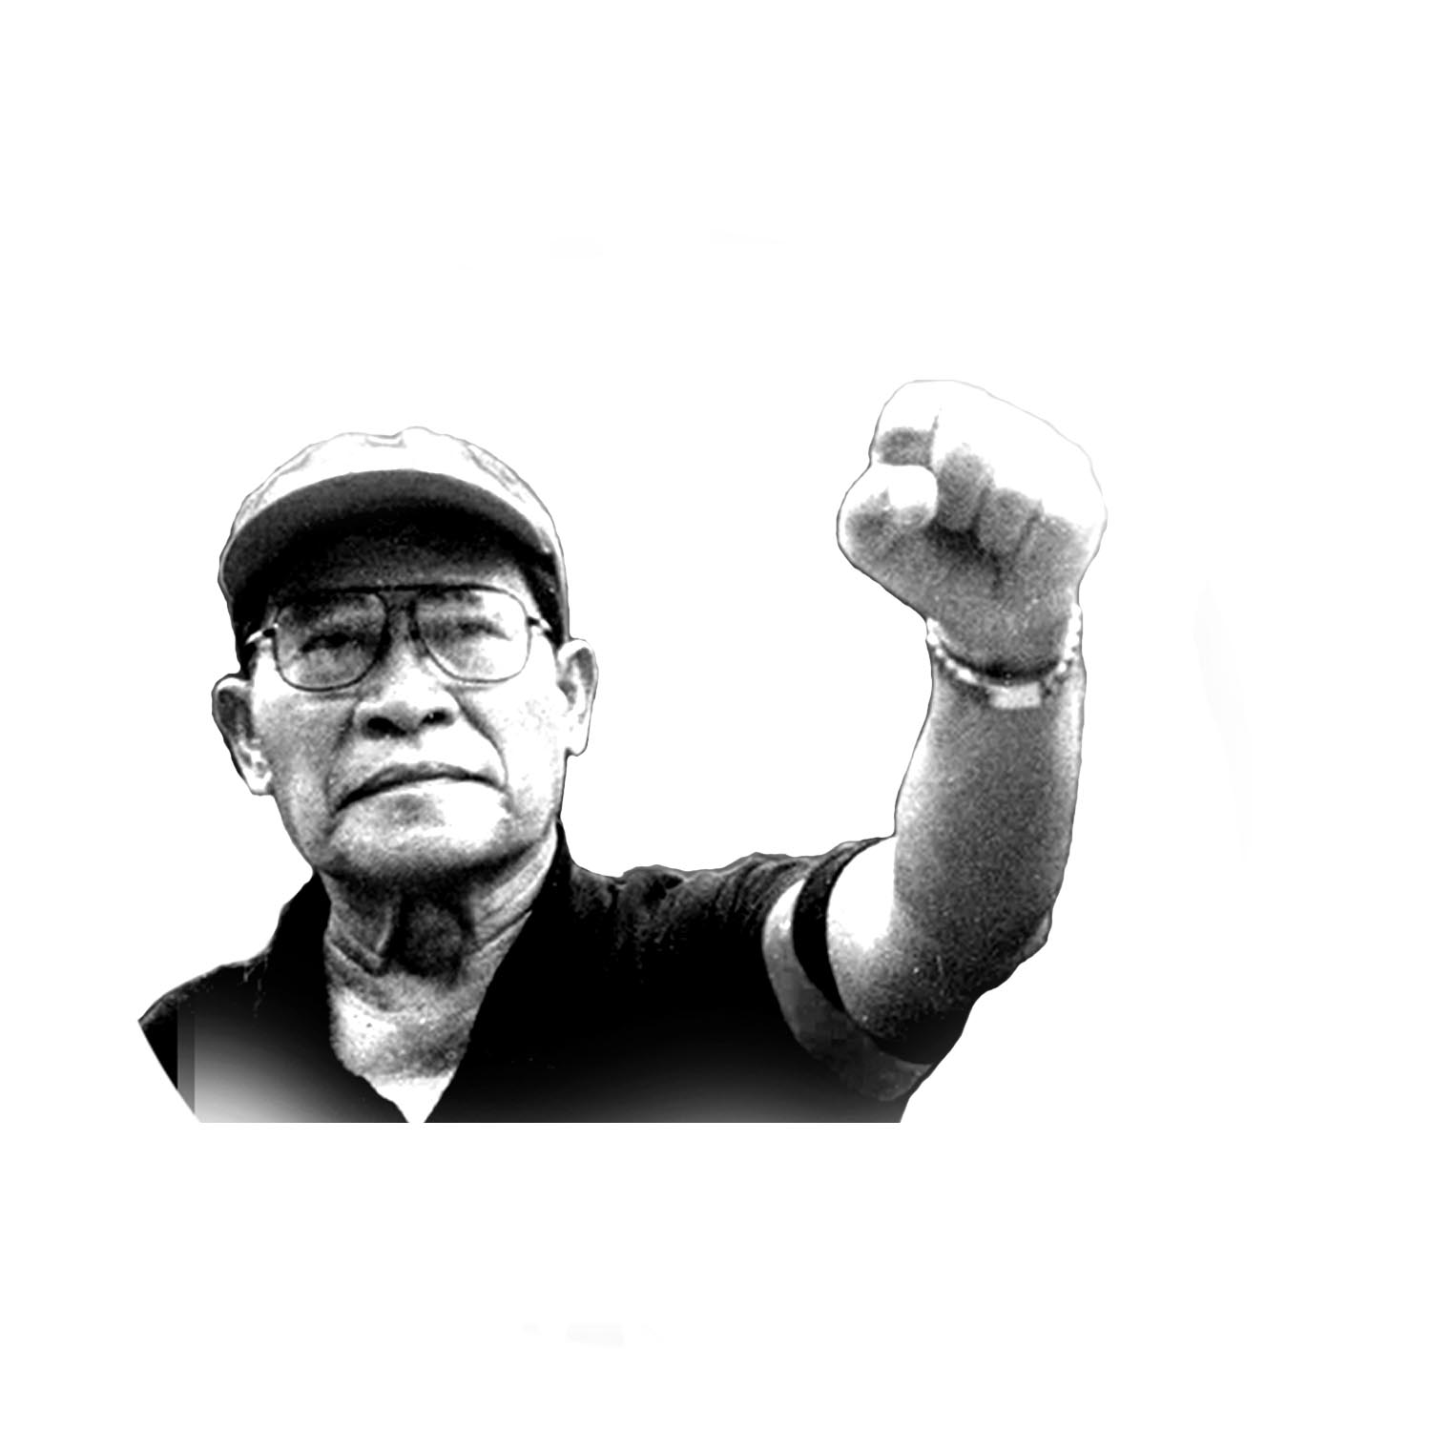
FREE KA BEL MOVEMENT

FREEDOM for KA BEL is
JUSTICE for the TOILING MASSES.

FREE KA BEL NOW!

International Forum for Ka Bel’s Freedom and against Political Repression
07 May 2007 / Manila, Philippines

The 2007 International Forum for Ka Bel’s Freedom is mainly organized by the Free Ka Bel Movement, together with the Kilusang Mayo Uno (KMU) labor center and the Center for Trade Union and Human Rights. The forum will be held hopefully within the premises of the Philippine Heart Center so that Ka Bel may join us during the forum proper, or at least so we can give him a solidarity visit right afterwards.

I. RATIONALE

Killings, Persecution
and the Multi-faceted political repression in the Philippines

Fighting for labor and human rights in the Philippines is constantly met with state repression. Not only is it manifested in the use of naked force in the forms of political killings, abductions and disappearances but also in the active manipulation of the law to persecute government critics.

The past six years under the highly questioned Gloria Macapagal-Arroyo presidency witnessed the worst and most rampant rights violations, surpassing even the combined records of the three post-Marcos regimes of Aquino, Ramos and Estrada.

As of March 2007, some 836 activists, journalists, church people, peasants, workers, and ordinary citizens from the various sectors of Philippine society had fallen prey to military and paramilitary death squads, without a single perpetrator caught and held accountable. This spate of extra-judicial killings is complemented with issuance of warrants of arrest in cases involving high-profile activists and government critics.

In spite of international pressures exerted on the Arroyo administration to stop the killings and persecution, state repression has not waned. On the contrary, it intensifies and is now legalized with the passage of Human Security Act (Anti-Terrorism Law) designed to criminalize activism and suppress the exercise of democratic rights under the guise of combating terrorism.

Repression, the ‘legal’ way

Long before this law is passed, the Gloria Macapagal-Arroyo government has already shown adeptness in manipulating the law to cripple her critics and to secure her grip on power. Amidst the scandals hounding the First Family, President Arroyo began issuing series of executive orders and memoranda requiring government officials to first secure clearance from Malacanang before testifying in congressional hearings. These are gag orders that only inflame the public interest to know the truth in issues involving her and other members of the First Family such as: alleged Arroyo-owned foreign bank account, the redirection of the national budget, siphoning of public funds and using them for her own promotion and publicity campaign in election 2004; assigning henchmen to key positions in government and in the Armed Forces of the Philippines.

Members of the First Family have also figured in the limelight. Presidential son and Congressman Mikey Arroyo filed a complaint before the House of Representatives Committee on Ethics against another opposition lawmaker for exposing an alleged Arroyo-owned foreign bank account. First Gentleman Jose Miguel Arroyo, on the other hand, has filed libel cases against 46 journalists for allegedly writing about unfounded accusations against him.

Five years of rule characterized by severe political repression and the implementation of anti-people policies coupled with legitimacy question proved too much for the Filipino people. The government’s pre-emptive steps, however, restricted peaceful assemblies and even declared quasi-martial rule on the 20th anniversary of the popular EDSA People Power Uprising through the imposition of Presidential Proclamation 1017 imposing a state of national emergency in the country. Ka Bel, a veteran labor leader, two-term lawmaker and four-time Most Outstanding Congressman, was among the first casualties.

Persecuting a people’s parliamentarian: the case of Ka Bel

It has been a year since Rep. Crispin Beltran, a duly-elected people’s lawmaker and five-time Most Outstanding Congressman awardee, was illegally arrested under the guise of being ‘invited to an interrogation’ by fully-armed operatives of the Philippine National Police (PNP) upon the orders of the Department of Justice - no arrest warrant, no explanation as to why he was being arrested. It was a violation of the Rules of the Criminal Procedure, of his rights under the Bill of Rights and of his immunity from arrest under the Philippine Constitution. It is also a violation of his right to presumption of innocence and against arbitrary detention.

At the police camp, he was presented a photocopy of an arrest warrant for a case that was effectively dismissed 21 years ago. He was then subjected to hastily conducted inquest proceedings and was falsely and maliciously charged with rebellion based on obviously fabricated evidence.

Two weeks of solitary confinement in a measly and ill-ventilated detention cell aggravated Ka Bel’s fragile health condition. His outrage over the illegal arrest, the trauma from his detention in the same camp during the dark days of Martial Law, and the inappropriate care at the camp’s hospital triggered his hypertension and led the court to grant Ka Bel’s counsels’ request for transfer to a private hospital. The psychological strain of being held for months without due legal recourse, as well as the stress brought about by the financial burdens of his year-long confinement at the Philippine Heart Center, however, remains a threat to his health.

It has been one year after the Supreme Court declared unconstitutional Proclamation 1017, yet Ka Bel remains illegally incarcerated. One need not have legal expertise to conclude that all evidence against Ka Bel are obviously fabricated, and his arrest and detention illegal – a truth that even the Inter-Parliamentary Union has acknowledged by passing a resolution demanding his immediate release. The Arroyo government, however, adamantly refuses to dismiss the cases against him and continues to disregard local and international calls for his immediate release.

Our Solidarity, His freedom

Ka Bel’s detention is not only a suppression of his individual rights and liberty. It is a strong attack on the toiling masses’ particularly the workers whose struggles and aspirations Ka Bel represents and asserts in the halls of Congress. Denying Ka Bel’s freedom, is denying these aspirations.

Freedom and justice for Ka Bel is freedom and justice for the working class, the toiling masses and for a nation fighting for sovereignty. And these can only be attained through our collective efforts and ardent solidarity. The Arroyo government has constantly disregarded and laughed off the worldwide clamor for Ka Bel’s freedom and shown enormous disrespect for human rights. It is high time we all gather and demonstrate our collective strength against political repression.

No state is too tough for a people determined to make human rights and freedom a reality. Let us all join hands and call on all human rights defenders and freedom fighters around the world to support this struggle. Let us to teach the Arroyo government respect for human rights and democracy. Let the resounding calls from around the world be heard: JUSTICE FOR KA BEL, JUSTICE FOR THE TOILING MASSES! FREE KA BEL NOW!

II. OBJECTIVES

- To provide a venue for supporters from the international community to gather and jointly campaign for Ka Bel’s immediate release.

- To review Ka Bel’s one year of unjust custody, as well as to exchange information on and assess the past year’s campaign for his freedom in various countries

- To provide updates on his over-all situation, and come up with resolutions as to how to strengthen and intensify the campaign for his immediate release in the participants’ home countries.

- To publicly call on the Arroyo government to immediately release Ka Bel and end political repression in the Philippines.

- To call the attention and get the intervention of other countries and international bodies and organizations such as the United Nations on Ka Bel’s case and on the general issue of political repression in the country

_ _ _ _ __ _ _ _ _ _ _ _ PLEASE PROVIDE ALL THE REQUESTED INFORMATION BELOW _ _ _ _ _ _ _ _ _ _ _ _

REPLY FORM

NAME: _______________________________________________
Age: ____________ Civil Status: __________ Sex: __________
Company: _________________________________ Occupation: _________________________
Organization: _______________________________ Position: ___________________________
Email Address: ____________________________________________
Postal/Mailing Address: ______________________________________

______ Yes, I / my organization will participate in the following activities:
___ May 07 FKBM, KMU and CTUHR-initiated Forum “Resounding Calls from Across the Globe: Justice for Ka Bel, Justice for the Toiling Masses! Free Ka Bel Now!
___ May 08-09 KMU-sponsored 23rd International Solidarity Affairs Conference
___ May 10 and/or 11 Solidarity Visit to Ka Bel at the Philippine Heart Center
___ May 12-18 Church-organized International Observers’ Mission
______ No, I/my organization cannot participate but am/is willing to support your campaign for Ka Bel.

Important:
Please email accomplished form and your comments (if any) to
Ms. Lyn Angelica Pano, International Officer, Free Ka Bel Movement at lynn.ap@gmail.com

