Action report.



Successful workers action

The 9 November Free Trade Zones & General Services Employees Union (FTZGSEU) held a successful event together with Progress Union and All Ceylon Federation of Free Trade Unions in Colombo, Sri Lanka. The action was a part of the unions counter campaign towards the initiative “Garments without Guilt”.

“Garments without Guilt” was launched two months ago by the Joint Apparel Association Forum (JAAF), the branch organisation of the Sri Lankan garment Industry. The purpose of the campaign is to market the Sri Lankan garment industry as an industry that ensures labour rights better than its competitors in the region. A few weeks later the above mentioned trade unions launched the counter campaign “Garments without Guilt? – The truth will come out in the wash” that urge JAAF to deliver what they promise.

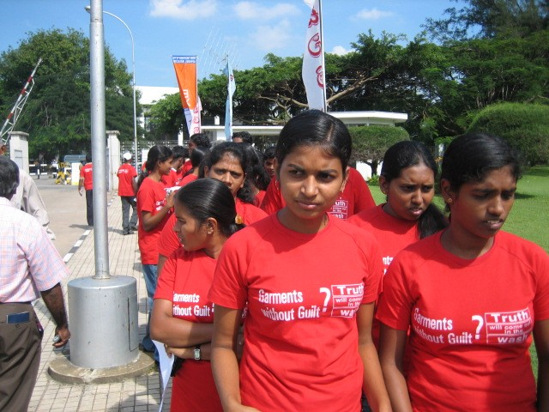
On November 9 the trade unions arranged what they called an “awareness-raising event” in connection with the JAAF co-arranged exhibition Fabric and Accessories Suppliers Exhibition (FASE). Over 200 FTZGSEU members and activists from all over Sri Lanka showed up nine o clock in the morning outside the exhibition area. Even though the area was guarded by the police the activists managed to get all the way to the exhibition hall. When the opening ceremony of exhibition started at ten a clock, the activists were standing right next to the entrance. Leaflets were handed out and interviews were given to media.

The Trade Unions declared that they fully agree with the JAAF that to ensure good working conditions is the best way to ensure a sustainable development for the garment industry in Sri Lanka. At the same time they are very keen to keep the credibility of the Sri Lankan garment industry and therefore want to highlight cases where good labour conditions are not present or violations of labour laws.

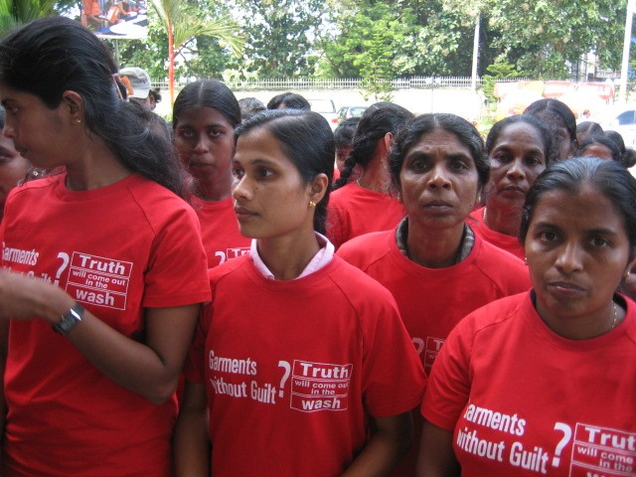
The message was that the workers and their representatives want to show their support for Garment without Guilt and also want to make a contribution. If JAAF give foreign buyers a guarantee that garments manufactured in Sri Lanka are manufactured under good working conditions, they also have to monitor the behaviour of their members to ensure this guarantee. With this extensive monitoring work the three trade unions have promised to constantly contribute.

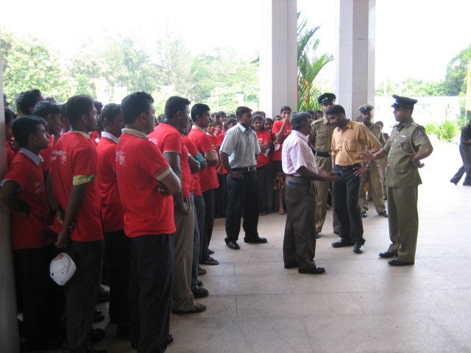
Except monitoring their members JAAF also need to be able to deliver what they promise. JAAF has filed a court case with the purpose to stop port workers from taking legal, collective, trade union action. The court case is under inquiry by ILO. You cannot claim good working conditions one day and undermine workers rights the next. This behaviour positions both Sri Lanka’s GSP Plus status, granted by the EU and the credibility of Sri Lanka’s garment industry at risk.

To ensure the future growth and credibility of the garment industry the trade unions urge JAAF to:
- Withdraw the court case against the port workers union.
- Ensure that their members follow labour laws and core labour standards and take action against members who don’t.
- Publicly state that without trade union participation it is impossible to ensure “Garments without Guilt”.

We would like to thank American Center for International Labor Solidarity, Sri Lanka for their support and contributions to this action.

We will keep you informed about the further development. If you need more information don’t hesitate to contact us.

Mr Anton Marcus
Joint Secretary
Free Trade Zones and General Services Employees Union
Email: ftzunion@diamond.lanka.net

