
Asia Pacific Workers Solidarity Links (APWSL)
Regional Coordinators Conference
Osan, Corea
Tel/ (82)-31-374-8582 Fax: (82)-31-372-9301
H.P.: (0082)-019-263-7972 E-mail: labrev@hanmail.net

"Building Asian Solidarity and Sharing Communication of internationalism and Revoiution"

PURPOSE OF THE CONFERENCE
  - Building Asian solidarity and inter-communication
  - Protecting rights of the Labor Internationally
  - supporting Migrant Workers Unions and building Leadership
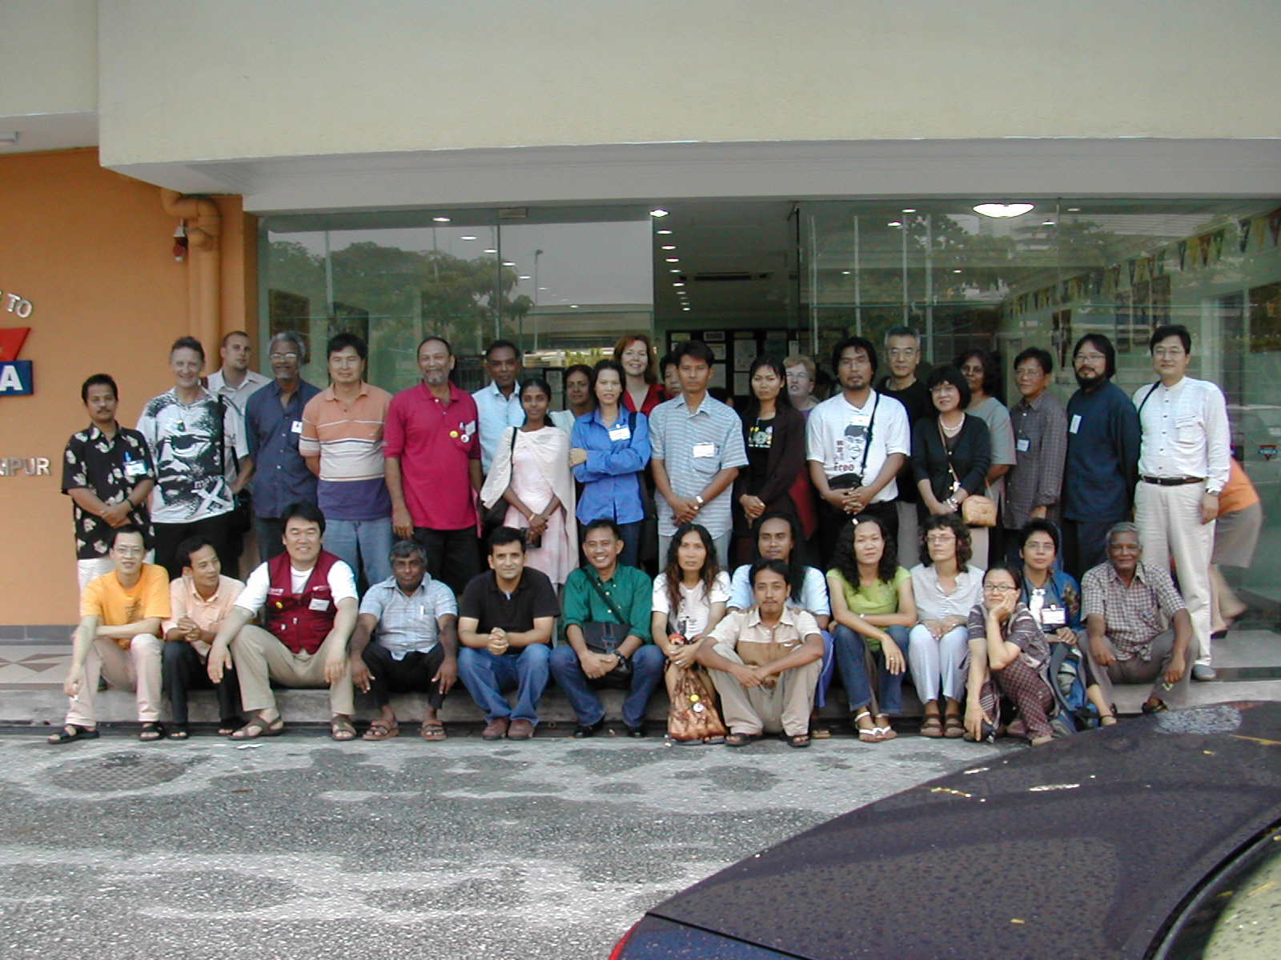
Parat Nanakorn,
APWSL Coordinator
Rev.Jang Chang Weon,
APWSL Convener
Ms. Gwyneth Evans,
APWSL Convener (W)
Tess Dioquino,
APWSL South Asia Regional Coordinator
Mr.Yamasaaki Seiichi,
APWSL East Asia Regional coordinator
Mr.Anton Marcus,
APWSL West Asia Regional coordinator
Ms.Carol Bridgens,
APWSL Pacific Regional coordinator
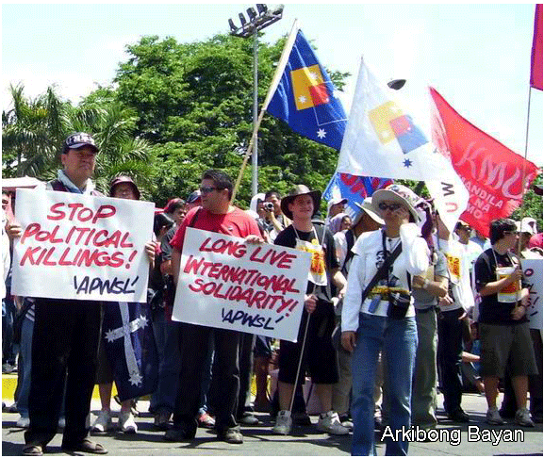
Opening on Monday 6 November
- Hanshin University
7th - Pyongtaek
8th - Kunpo city,
9th - Yongdong. Kumi
10th - Daegu
11th - Seoul
Closing on 12th- Labor Day
(Jon Tae Il Memorial Day)

