Asia Pacific Workers SolidarityLinks
70/97 Moo 3 Tumbol Klongnueng, Klongluong, Pathumthani 12120, ThailandTel: 0-2902-1740 Fax: 0-2902-1810 Mob: 0-9517-2087 email: nanakornp@gmail.com

WTO – International institution of violence against human rights 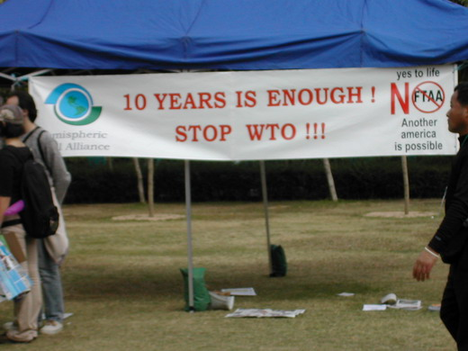

“Down! Down! WTO!” “Kung Yee Sai Mau”
These two slogans were always chanted during the action against WTO in Hong Kong. Even when I was detained in the police station in Hong Kong, I kept hearing these two slogans in the 24 hours detention. The protest to the 6th WTO ministerial conference in Hong Kong was the most horrible yet the most meaningful experience in my life. I would like to share this experience with my comrades in APWSL.

In the Melbourne planning meeting in October, it was decided there were two objectives of the Hong Kong mission. Firstly, we have to convene a secretariat meeting for APWSL. Secondly, we also had to carry out a strong action against WTO.
So Pi Suganda, an unionist from the Rangsit area who newly became the APWSL member and me arrived Hong Kong on the 12th of December. The APWSL have our meeting on 14th of December. Then we participated in the women’s march on the 15th of December. We also participated in a protest against the Nest Café Company on the 16th of December. In fact, we almost participated in actions and activities against the WTO in the Victoria Park and other demonstration area everyday. However I had never imagined I would end up injail. It was the most direct violence from the WTO that I experienced.

The violence from WTO is not new for me. I learned about WTO in a series of seminar on globalisation at Chulalonkorn and Thammasat University since 1995. I also knew that the former body of WTO was GATT. I wanted to understand the impact of globalisation on the grass root people so I tried to get more information from reading materials and news. At that time the impact of WTO was not very well known. Only until 1997, when Asian economic crisis hit most of the economy in SE Asia, the Thai people began to understand the real impact of globalization. Many workers were layoff and became long term unemployed after the crisis. All the WTO promoted policy were begun. For example, flexible employment , privatisation and set up Free Trade Zone to attract foreign direct investment

Supachai from Thailand was the last secretary of the WTO. He earned a lot from his work, however, he did not work out any good policy on Thailand when his was working for WTO. During his term, Thailand carried out privatization on oil (petroleum). The government explained to the public that they have to trade other profit by selling oil (petroleum). However it should be a national asset. How can the grass root afford the expensive petroleum after privatisation?

The impact of globalization was not only on the workers. It also have impact on the farmers . Since I came from the agricultural family which grew coffee, I also very concern the farmer’s situation. The Asian Development Bank came to Thailand to provide loan for dam construction. Although the project provided water to the farmer for irrigation, the farmer have to pay a lot for the water supply. Besides, the project also made the whole country in debt and created negative impact on the environment.

I also saw the big impact of WTO on other poor countries. Like many other developing countries, we have to produce own food for self-sustain. Many big company attempted to take over agriculture from the small farmer in all over the world. The big companies pressurised the government promote policy which allow them to maximise their profit. It end up, the small farmer either have no land to farm or own a big debt which they can never pay back in their life. I learned from the protest in Seattle and Cancun Ministerial conference that many farmers committed suicide due to the negative impact from the WTO policies. Many farmers’ group have join together to fight against WTO. I think we have to support them.

The WTO did not solve any problem and most of the time made the situation worst. Therefore I decided to join the protest against the WTO in HK as I don’t want to see the world monopolised by TNC. In fact, the WTO conference has been very famous on attracting protestors from all over the world in every conference. It is own rights to against it. In Hong Kong ministerial conference, the WTO use the host government to arrest people who protest against it. Although I experienced the worst treatment from in Hong Kong, I did not blame the HK police. It is because the Hong Kong police did not understand the sufferings we have and they were manipulate by the WTO. The real monster is WTO who kill us everyday.

It had been very difficult to educate the workers on the issue of WTO. It was not because of the workers are not capable to learn. The education was blocked by barriers of access to information. The experience of participation in all the actions and activities with people from different countries, detention in the Hong Kong prison and the solidarity support from Hong Kong People Alliance on the WTO (HKPA) and the Hong Kong citizens will become the best education material to my fellow workers, farmers, women and people from all walks of life in my country. .

Asia Pacific Workers Solidarity Links
Minutes of the Hong Kong Meeting
14 December 20005 At HKCTU ’s office
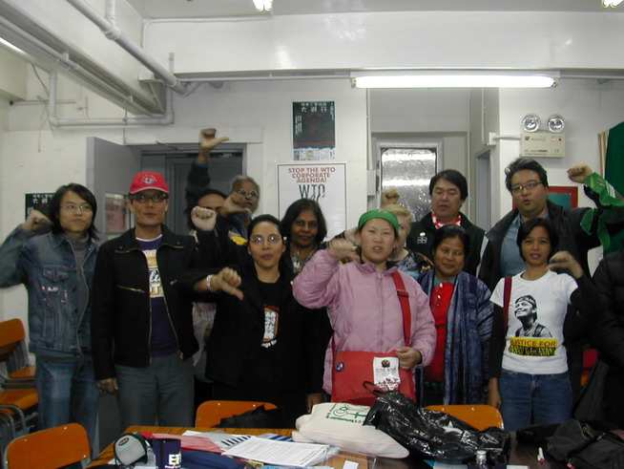
- Present:
  - : Parat Nanakorn Coordinator Thailand
  - Rev. Jang Chang Weon Convernor Korea:
  - Sugarnta Sookpaita Trade union from Rangsit area, Thailand
  - : Sinapan Samydorai Singapo
  - Tess Dioquino KMU Philippines:,
  - Imam Rahmana, LIPS - Indonesia
  - Apo Leung, AMRC Hong Kong:
  - Franklen Choi, HKCTU Hong Kong:
  - Chan Yan Kam, Hong Kong:
  - Seto Chun Pong Hong Kong:
  - Billy Sejo Hong Kong
  - Yukihiro Yasuda Labor Net Japan
  - Makoto Kawasoe Labor Net Japan.
  - Tang Shiu Labour Rights Association Taiwan
  - Sandy Peng Labour Rights Association Taiwan
  - Karen Moran, AAWL Australia

- Observers:
Irene Xavier, Tie-Asia Malaysia

This Special APWSL meeting is an Exchange with APWSL Hong Kong and those APWSL’s member who were in Hong Kong for the Anti-WTO protest. The key objective was to establish contact with APWSL Hong Kong.
APWSL Hong Kong: Is an informal network of Labour groups which are individually active and keep in communication.
Apo Leung – AMRC
Franklen Choi – SEPI/HKCTU
Chan Yan Kam – Diocesan Pastoral Centre for Workers
Seto Chun Pong - Neighbourhood & Worker’s Service Centre
Key Labour Issues:
  - Flexibilization,
  - Contractualization
  - Hong Kong labour Movement is divided: Hong Kong Confederation of Trade Unions [HKCTU], Hong Kong Federation of Trade Unions [HKFTU] and the Neighbourhood Services Centres. * APWSL HK is linked with the HKCTU.
  - Union [Workers] Consciousness of people undeveloped, union organizing is difficult; but there are informal networks eg. Public Assistance Network, Global Network, etc
  - SACOM – the Hong Kong groups Consumer Movement is focused on the Hong Kong based MNCs like Giodano [Disneyland products] eg low wages ..etc
Difficulties:
  - Disruption in communion due to the fact that the [older] leaders speak little [no records or papers on APWSL] with the new leaders [younger members].
  - The new leaders had not previous contact with APWSL. How to improve the contact, communications, improve language with translation ..etc
APWSL – Coordinator: Parat Nanakorn
- Convenor: Rev Jang Chang Weon
  - Report on the visit and exchange in Australia/AAWL [*refer to report distributed]
  - Share on the Financial situation
  - All affords have make to seek a simple financial report from the [former coordinator and those responsible] but the report was not submitted.
  - It was felt its better to move on to facilitate the new coordinator.
  - Request Japan to rethink it position on full financial report from the former coordinator.
  - The need for accountability is important. But the new APWSL coordinator/team should not be disadvantaged.
  - Each national APWSL should make financial contribution
  - WSF Mumbai meeting there was no funding available but there was contributions that enable the APWSL participation
  - Newsletter: Asia Pacific Workers Solidarity Links, was distributed
  - Website: Rev Jang is developing the website.

Indoesia LIPS: Iman
He works with LIPS that collaborate with various labour organizations but is not involved in organizing workers. LIPS focus more on research and information gathering.
APWSL members like Humanika and YPP are organizing workers.
Most activities are not related to APWSL network. For long period the Indonesian labour groups have identified with APWSL network, especially with APWSL Korea. For example, support the Korean Garment and Chemical Workers Union exchange in Indonesia.
Iman has been to Korea where he met Rev. Chang and he also stayed and life with workers.
Cultural Exchange Programme Indonesianand Korean in the coming year. In Jan 2006, possible exchange in Surabaya for one week, 6 persons from Korea.

Philippines KMU : Teresa
KMU acts as the Sub-Regional coordinator for APWSL members in Southeast Asia.
Philippines Situation:
  - consolidate membership
  - increase in minimum wage to Peso 135
  - political repression, 40 union & peasant leaders killed
  - labour rights, organizing workers is being repressed eg mill workers union
  - Hecienta struggle successful expect for land ownership rights eg, increase in wages, reinstate retrenched workers, seed money for agricultural workers/families [Peso 200,000], till 100 hectares for crops as individuals and collective..etc
  - International Solidarity Day for Workers [May Day] to focus on political repression.
APWSL Singapore: Sinapan Samydorai
  - Hosted the vist of Rev. Jang and Ms Parat on their way to Australia, Oct 2005.
  - Parat was accompanied by Thai Trade unionist
  - Visit Thai Migrant Workers group

APWSL Japan * Yamasaki was not able to come to Hong Kong.
  - LaborNet Japan
  - Supports communication work of APWSL
  - Builds the LaborNet Asia [technical support]

AAWL: Karen Moran
  - Karen distributed gifts and t-shirts make in Australia
  - Distribute the APWSL newsletter

