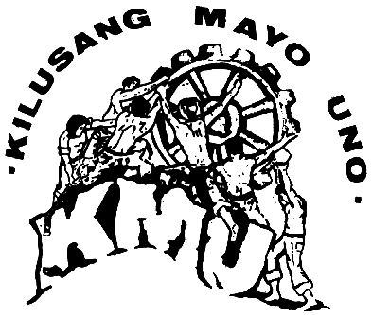
KILUSANG MAYO UNO
(May First Movement Labor Center)
TAGAPAMANDILA NG TUNAY NA UNYONISMO
No. 63 Narra St. Bgy. Claro, Proj. 3 Quezon City, Philippines
Telfax 421-0768/421 1049; Ph: 421-0986 Email: kmuid@tri-isys.com
____________________________________________________________
KMU is a founding member of the International League of Peoples’ Struggle

7 February 2006

Dear fellow Trade Unionists and Supporters,

The National Executive Committee of the Kilusang Mayo Uno extends its warmest greetings to you and your organization.

We wish to inform you that the KMU is holding its 22nd International Solidarity Affair (ISA) on April 29 - May 9, 2006 in Manila, Philippines.

In the last 10 years, we are witness on how imperialism has gone berserk, becoming ever-more plunderous and exploitative. We have witnessed how the International Monetary Fund (IMF), World Bank (WB), World Trade Organization (WTO), free trade agreements (FTAs) and other instruments of imperialism have ravaged the world’s resources. Jobs are being destroyed, wages are being frozen and democratic rights long won by the workers thru arduous struggles are slowly being taken away.

Yet, in the same way, we have witnessed how the people of the world, led mostly by the workers, have shown resilience and strength to counter these imperialist offensives.

Right in the very eyes of the workers, we see the dawn of a new tomorrow gradually unfolding. The peoples’ victories in Venezuela, Bolivia and Chile are clear examples of how the people abhor imperialism and its lackeys. We see how the workers in Australia fight against labor law amendments that aim to destroy their lives and their future. We see South Africans rising against worsening trade union situation. We see Nepal taking up the challenge of fighting a dictator. In the belly of the beast, trade unions play a big role in the massive protests against US war of aggression on Iraq and other countries. In so many parts of the world, the workers are rising as a dynamic force fighting monopoly capitalism at its very core.

But the resurgence of the workers movement also resulted in a heightened counter-offensive of the imperialists and big capitalists, both in the economic and political field.

In the Philippines, political killings has exacerbated at a very alarming level. Last year, more than 200 political activists that include trade unionists were killed by suspected military agents and soldiers. Economic and political terrorism is the battlefield of the imperialists in trying to suppress workers’ resistance.

Against this backdrop, it is important to take stock of the workers’ experiences, the losses and gains in their struggle to emancipate their ranks. These shining examples should be reviewed so as to get innumerable and vital lessons in continuing and advancing to greater heights the struggle of the working class.

It is in this context that the KMU is holding the 22nd KMU ISA this year with the theme “An Update on the Surging Trade Union Resistance Amid Heightened Attacks of Imperialist Globalization”.

We therefore invite you to join the 22nd KMU ISA. Attached herewith is a concept paper of the event.

We hope to hear from you at the soonest possible time.

In solidarity,


Elmer C. Labog
KMU Chairperson

